MSME IDEA HACKATHON 5.0 PROPOSAL

- TITLE – CRASH SENSE -Vehicle Crash Detecting System

- Problem Statement (Min 200 words)
Road accidents are a major cause of fatalities, and delayed emergency responses worsen the situation. Existing crash detection systems often rely on camera visuals, leading to false alerts due to shadows, moving objects, or poor lighting. These systems fail to respond when the camera is actually damaged the most critical moment. There’s also a lack of integration with real-time data like g-force and vehicle speed, which are key indicators of crashes. Additionally, alerts are either missed or sent too late due to inefficient automation. A reliable system is needed that activates only on real camera damage or heavy force, not visuals. It should include a short cancel window, store full driver details, and send precise SOS alerts for timely emergency response.
- Description of the Project (Min 500 words)
CrashSense is a real-time vehicle crash detection and alert system designed to improve road safety by identifying genuine crash scenarios using G-force, high vehicle speed, and camera failure. Unlike traditional systems that depend on visual object detection or frame analysis, this system confirms accidents only when the onboard camera becomes non-functional following a strong physical impact. This approach eliminates false alerts caused by minor object movement, dark frames, or camera blur, ensuring high reliability in real-world usage.
The system continuously monitors G-force and speed, and upon crossing the set thresholds, it checks for camera failure to validate the crash. 15-second countdown alert window allows the driver to cancel in case of false detection. If not canceled, an automated SOS is sent via SMS using Twilio, including the driver’s name, vehicle details, location , and crash timestamp. Developed in Python, the system uses Tkinter for GUI, OpenCV for camera input validation, Geopy for location simulation. CrashSense is hardware-ready, compatible with devices like Raspberry Pi, and offers a practical, affordable safety solution for personal vehicles, fleets, and transport services.
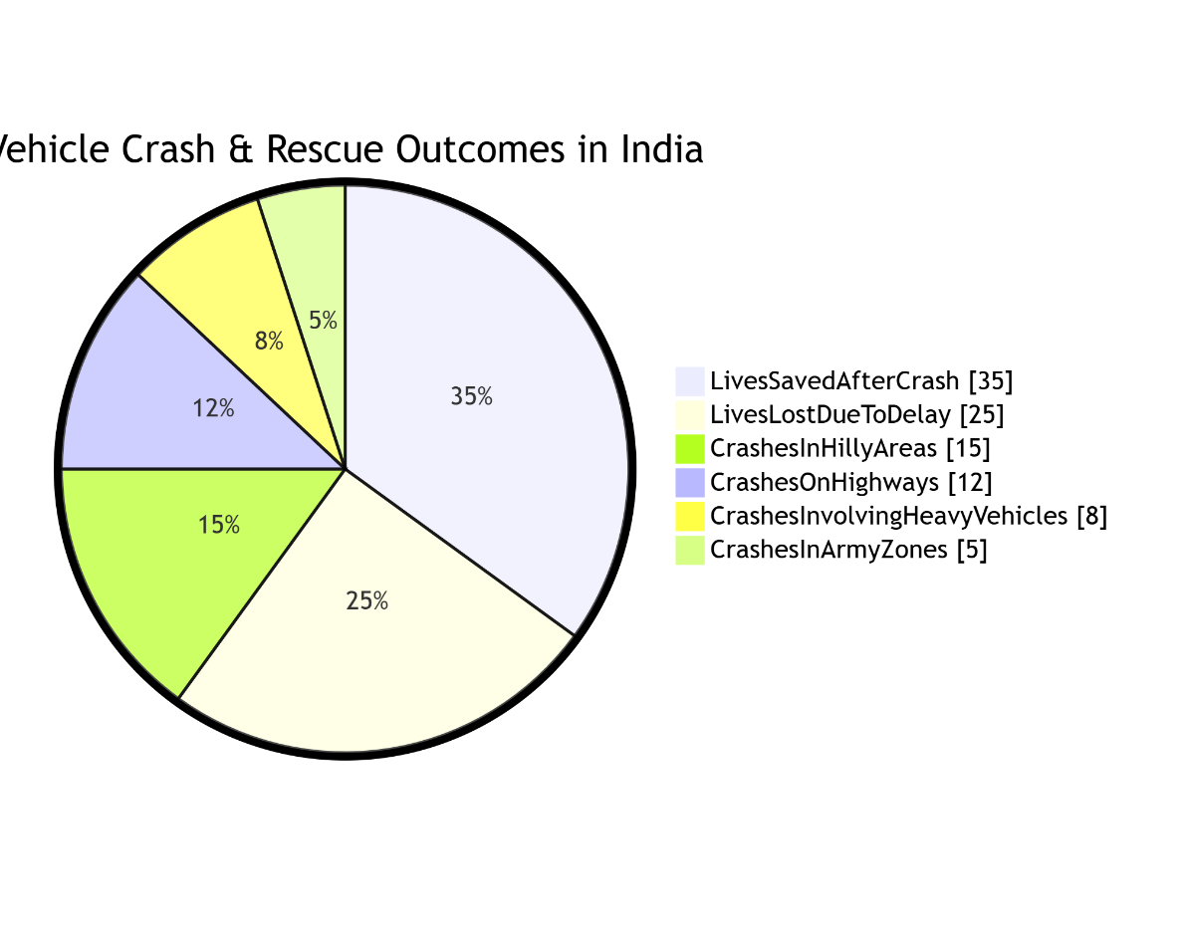

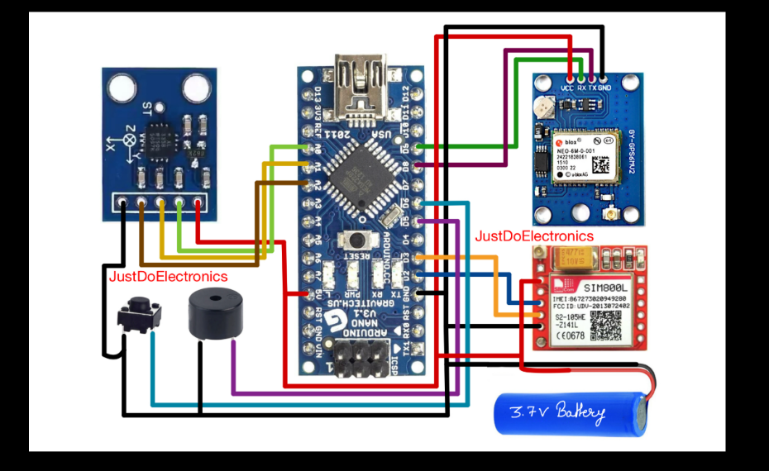

- Technical Details of the Project (Min 1500 words)

- A complete Python-based crash detection application with GUI integration.
- A hardware-compatible crash alert system ready for deployment in vehicles.
- Real-time G-force and speed simulation with crash detection logic.
- SOS alert feature integrated with Twilio SMS API for real-time messaging.
- Driver and vehicle registration and alert display panel.
- Camera feed-based impact validation .
- Documentation for installation, configuration, and deployment in real environments.

Use-Cases :
- Detects real-time vehicle crashes only when the system’s camera is physically damaged or disconnected, ensuring accurate crash reporting without false alerts.
- Sends automatic SOS alerts containing driver name, contact, emergency numbers, vehicle ID, address, and live location to emergency contacts via SMS.
- Reduces time delays in emergency response by automating alerts, helping to prevent fatalities during severe crashes.
- Can be integrated with hardware modules like Raspberry Pi, accelerometers, GPS modules, and GSM modules, enabling full deployment in real vehicles.
- Supports monitoring in logistics and transport fleets, ensuring quick response during accidents for commercial vehicles..

Technologies & Modules Used
Python- Main language for system logic, monitoring, and UI.
Tkinter- Builds GUI for monitoring and SOS alert interface.
OpenCV - Checks camera functionality triggers alert if feed fails.
NumPy- Handles numerical operations in frame analysis.
Twilio API- Sends SOS messages with crash details.
Geopy- Simulates GPS location (to be replaced with actual GPS module).
Threading- Runs detection and GUI processes concurrently.

Sustainability Impact
Life-Saving Emergency Alerts
Detects real crashes based on camera failure and G-force, reducing fatal delays.
SDG 3: Well-Being
Low-Cost, Inclusive Safety
Uses affordable hardware for widespread adoption in low-income regions.
SDG 10: Reduced Inequalities
Modular Integration
Easily fits into various vehicles for scalable deployment.
SDG 9: Industry, Innovation, and Infrastructure

- Briefly explain newness/uniqueness of the innovation (Min 500 words)

- Sensor-Based Detection: Uses G-force and speed data to detect real crashes, eliminating false alerts.
- No Visual Detection: Does not rely on object or frame analysis ignores blur, darkness, or moving objects alerts only on real camera failure.
- Accurate SOS Alert Mechanism: Triggers a 15-second GUI countdown window after impact allows the driver to cancel if the alert is accidental.
- Emergency SMS Integration: If not canceled, sends detailed SMS alert via Twilio with driver info, vehicle details, timestamp, and GPS location.
- User-Friendly Interface: Built using Tkinter GUI displaying status like Monitoring Vehicle and showing live G-force and speed values.
- Reliable & Efficient Code Design: ensures clean alert flow, SMS handling, and driver input validation.
- Tech Stack: Integrates Python, OpenCV, NumPy, Geopy, Twilio, Tkinter, and threading for smooth multi-tasking.
- Hardware Ready: Designed for real deployment on Raspberry Pi/Arduino with accelerometers, GPS, and GSM modules.

- Detailed Objective (Min 500 words)

Concept
- CrashSense is a real time vehicle safety system that detects major crashes using G-force and speed, not visual input.
- It identifies only genuine crashes by detecting hardware level issues like camera failure due to impact.
- The system avoids false triggers from blurred frames, object movement, or visual disruptions.
- On crash detection, it collects driver, vehicle, and location data and sends automated SOS messages to emergency contacts.

Objectives
- Detect real crashes based only on physical force or physical impact
- Eliminate false alerts by avoiding visual-based detection.
- Trigger an SOS alert with a 15-second cancel option.
- Include full driver and vehicle details with location in the alert.
- Enable quick emergency response without manual intervention.
- Potential areas of application in industry/market in brief (Min 1500 words)

- Automotive Industry – Integration into personal and commercial vehicles for real-time crash alert functionality.
- Fleet Management – Monitoring and safety assurance for logistics and delivery vehicle fleets.
- Emergency Services – Automated crash alerts help dispatch medical/rescue teams quickly after real incidents.
- Connected Vehicles & Smart Mobility – Integration into smart cars using sensors and GPS modules.
- Insurance Sector – Real crash data assists in verifying claims and detecting fraud.
- Electric Vehicles – Enhancing safety features in low cost or developing vehicle segments.
- Ride-Sharing and Rental Services – Ensures rider and driver safety through immediate crash notifications.
- Public Transportation – Applicable to school buses and public transit for improved accident response.
- Defense & Military Transport – Real-time field crash alerts in high-risk, remote, or mission-critical operations.
- Highway and Road Safety Authorities – Enables proactive response systems to roadside accidents.

- Briefly provide the market potential of idea/innovation ( Market Size) Min 1500 words

- Offers an affordable and practical crash detection system that works even in low-cost or older vehicles, unlike expensive traditional systems.
- Detects only genuine crashes using G-force and speed thresholds, avoiding false alerts caused by visual issues like blur or low light.
- Sends immediate SOS messages with driver, vehicle, and location details—reducing emergency response delays and potentially saving lives.
- Ideal for wide industry use: passenger vehicles, logistics fleets, school and college buses, ambulances, defense transport, and two-wheelers.
- Compatible with affordable hardware like Raspberry Pi, Arduino, GSM, GPS, and accelerometers—suitable for budget-conscious markets.
- Can be adopted by developing countries where accident rates are high and advanced vehicle safety systems are limited.
- Commercialization possible via multiple models: software add-ons, OEM integration in new vehicles, or fleet-based deployment services.
- Encourages partnerships with automotive service centers, telecom providers, and public transport agencies for mass adoption.

- Prototype (If Already Available)

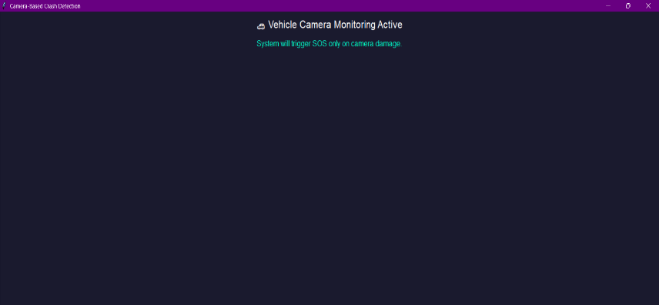

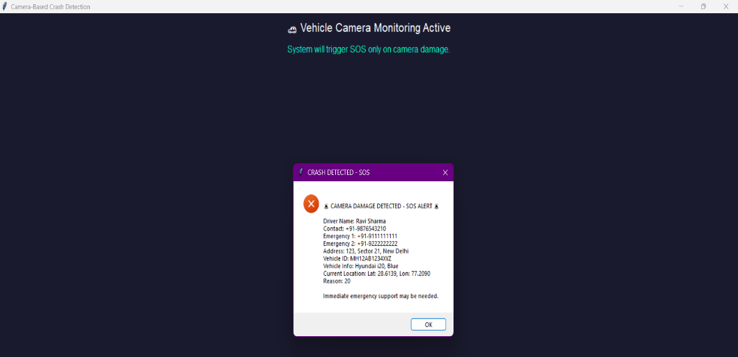

- Expected Outcomes (Min 250 words)

- Detects real crashes using G-force and speed data.

- Triggers SOS only on hardware-level impact or camera failure.

- Sends emergency alerts with driver, vehicle, location, and time.

- Allows 15-second window to cancel false SOS alerts.

- Displays real-time G-force and speed on the interface.

- Fetches accurate location using GPS modules.

- Easily integrates with Raspberry Pi, Arduino, and sensors.

- Affordable solution for older or low-end vehicles.

